Weather Outage Prediction in Power Grids in Databricks

By: Aaron Pongsugree

ECE606

Abstract

This paper presented supervised machine learning approaches for predicting weather-related power outages using data from the U.S. Energy Information Administration and National Oceanic and Atmospheric Administration. A thorough analysis regarding the implementation of the proposed engineering pipeline using Databricks and PySpark to process and analyze historical outage data’s relationship to publicly available historical records of power grid outages and weather data was conducted. Varying feature sets analyzed with multiple machine learning models, including logistic regression, random forest, gradient boosting, and an ensemble algorithm consisting of the combination of the previous models, were evaluated. Experimentation resulted in achieving prediction accuracies ranging from around ~62-72%. Furthermore, results demonstrated the potential for proactive power grid management through weather-based outage prediction.

- Introduction
The reliability of the power grid infrastructure is crucial to society and must maintain high availability and minimal downtimes. A significant number of these outages are due to severe weather-related events. This research aims to provide a cost-effective implementation of weather-based outage predictions by analyzing real-world power grid outages and weather data. A data engineering ETL pipeline to develop the datasets was implemented along with supervised machine learning algorithms to predict potential disruptions, enabling proactive maintenance and resource allocation.
The contributions of the work include:
- Development of a comprehensive data engineering pipeline in Databricks
- Implementation and comparison of multiple machine learning models for outage prediction
- Experimentation with varying number of features
- Analysis of feature importance in weather-related outage prediction

- Background & Motivation
Power grids experience many outages throughout the years from various issues such as required system maintenance, security attacks, and leading by a majority, severe weather conditions. Power grid reliability is an increasingly critical component for nations with an increasing dependency continuously rising as advancements in artificial intelligence cause increasing load demands resulting in more strain on the power grids.

Traditional reactive approaches to power grid maintenance and outage responses are inefficient and results in poor outage responses for customers.
Power grid reliability is an ever-growing industry as the demand for uninterrupted electricity drastically increases as technology advances. Traditional approaches relied heavily on human labor through the analysis of significant amounts of historical data. The power grid has evolved to incorporate a multitude of smart meters with a growing emphasis on proactive mitigation strategies. With the significant amount of data available from US weather stations coupled with power grid outages, a strategy can be implemented to improve reliability in smart grids.
Current challenges motivating this research involve climate change and an increasing frequency and severity of weather conditions. Complexities in power distribution networks and a need for improvements in proactive decision making and resource allocation were also aimed to be addressed.
The advancements in machine learning algorithms for the use of infrastructure management has shown promising results. Previous research has been conducted regarding fault detection and classification within the power grid. This research builds upon other works regarding load forecasting, equipment maintenance scheduling, and other power grid optimizations with a distributed computing platform.

- Related Works
Many related research studies have been conducted in power grids, machine learning for advanced data analytics, and improving reliability in the infrastructure to prevent disruptions. The increase in available data, both external sources such as weather conditions as well as the data within power grids due to the increased utilization of smart meters have resulted in a requirement for more advanced data analytics technique to be applied on potentially vast amounts of data.
In the data analytics of power grids, Shen et al. [1] developed a comprehensive flexible ensemble algorithm for cleaning and analyzing Phase Measurement Unit (PMU) data. The authors approach combined multiple detection techniques including PCA-KMeans, Gaussian Mixture Models (GMM), and isolation forest detectors within a unified framework. The implementation of the solution was accomplished using Apache Spark, where they demonstrated a computationally efficient and large-scale deployment strategy for anomaly detection in PMU data. The work primarily focused on identifying outliers and cleansing the data using a combination of ML approaches. The multiple algorithmic approaches proved to effectively handle the complex and multi-dimensional nature of power grid data achieving more than 90% accuracy in test scenarios.
Another research conducted by Huang et al. [2] made significant contributions in the power grid industry by applying random forest techniques in material demand forecasting. Their research achieved prediction accuracies surpassing 90% across diverse power grid component categories. Although the focus of this research was not based on outage predictions, their methodology for feature selection and model optimization established important principles for handling complex and interdependent variables commonly present in power grid applications.
Research more specifically focused on identifying cascading faults under extreme weather conditions was conducted by Hou et al. [3]. A power system simulation tool, Bonneville Power Administration (BPA) simulation software was used to propose a framework tightly integrated with meteorological models to identify fault propagation through grid networks caused by ice and snow conditions. The overall contributions of this research provided a foundation for developing advanced techniques for improving the accuracy of fault prediction models during extreme weather events to better analyze complex weather and grid relationships.
Hoiem et al. [4] conducted an extensive comparative analysis of supervised machine learning techniques for power grid event prediction. Their research analyzed high-resolution power quality data to evaluate multiple machine learning approaches including Support Vector Machines (SVM), random forests, feed-forward neural networks, and recurrent neural networks (RNN). Their results showed that the random forests achieved the highest accuracy at 60.2% highlighting the potential of machine learning approaches in this domain. Kaur et al. [5] further expanded on deep learning implementations in power grids by implementing an RNN-LSTM architecture for smart grid management. Their deep learning-based approach demonstrated superior performance in handling the temporal aspects of grid data, providing valuable insights for predictive maintenance and outage prevention strategies.
These research papers and similar works provide several modern advanced data analytics techniques, frameworks, and exploration of different platforms for improving power grid reliability. These works provided a foundation for the research presented throughout this paper, using Apache Spark and a distributed computing platform, Databricks, to develop multiple supervised machine learning models to identify potential weather outages in the power grid based on available weather data metrics.

- Technical Solution
Databricks, a distributed computing platform for data ETL processes and building machine learning frameworks was used for developing a solution to analyze weather data outages in the US power grid. AWS was the cloud computing platform used for storage and workload management of the Databricks environment. The Databricks environment’s configurations had the following specifications:
- Runtime: Databricks 14.5 LTS (Apache Spark 3.5.0, Scala 2.12)
- Cluster Configuration: 1-4 Workers, 16-64 GB Memory
- Worker Type: r5d.large (16 GB Memory, 2 Cores)
Additionally, AWS S3 was used for storage, PySpark for distributed processing, and the EC2 instances in the AWS console were monitored to ensure no performance bottlenecks. The required IAM policies were manually created and attached to the bucket, as well as updating the bucket policy to allow the Databricks environment to read and write to S3. The IAM policies to set up the VPC connectivity and allow Databricks cluster to use EC2 instances from AWS as worker nodes were configured and verified. Significant time was spent resolving cloud permissions and configurations before the Databricks environment was properly set up.
The data processing followed Databricks’ Medallion Architecture for implementing a robust ETL pipeline with three layers as follows:
- Bronze Layer
  - Raw data ingestion from OE-417 reports and NOAA weather data
  - No schema enforcement
  - Preserve original data attributes and relationships
- Silver Layer
  - Clean and transform the data
  - Remove null values, standardize the data
  - Combine the datasets
- Gold Layer
  - Feature engineered tables optimized for machine learning
  - Weather-outage correlation data per day and per state
  - Creation of dataset for training and evaluation of ML models
  - Business-level insights

Figure 1 - Bronze (raw) -> Silver (cleaned) -> Gold (processed) data storage implementation
Two raw datasets were obtained from multiple sources including the US Department of Energy or Energy Information Administration (EIA) and the National Oceanic and Atmospheric Administration (NOAA). The first batch of data was obtained by downloading 10 publicly available Excel files from the US Department of Energy’s website for Electric Disturbance Events (OE-417) for the years 2013-2023.
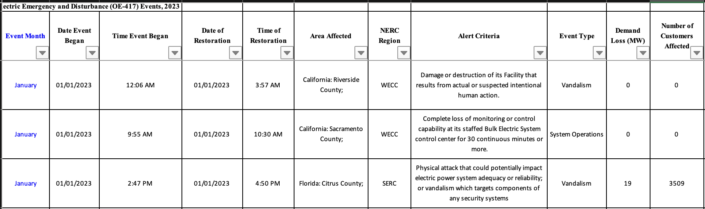
Figure 2 - Example of raw OE-147 data from 2023
The 10 yearly grid outage annual data was locally converted to csv format and uploaded to an S3 bucket which the Databricks environment could read and write to. The raw data for power grid outages had to be cleaned extensively as the format of each file lacked data standardization implementations year to year. After individual cleansing of each annual file, they were combined to have around 3000 records. Further extractions by state were performed to improve the data quality as well as reformatting of the date and other minor enhancements. Then, the weather data from NOAA was obtained by identifying the unique combination of states and dates to gather metrics including minimum temperature, maximum temperature, precipitation, and wind speed. That data was then joined with the combined OE-147 data for the 10-year duration. Additional data cleansing to remove outliers, standardize null values, and remove rows with too much missing data were conducted again to improve data quality and then stored in the silver layer or the cleaned directory. The event type column was then parsed and if it contained the word “weather” disregarding case sensitivity, then a value of 1 was inputted into a new weather outage classification column, otherwise 0. This was the gold data that was stored in the processed directory that was used for further analysis, with an example shown below.
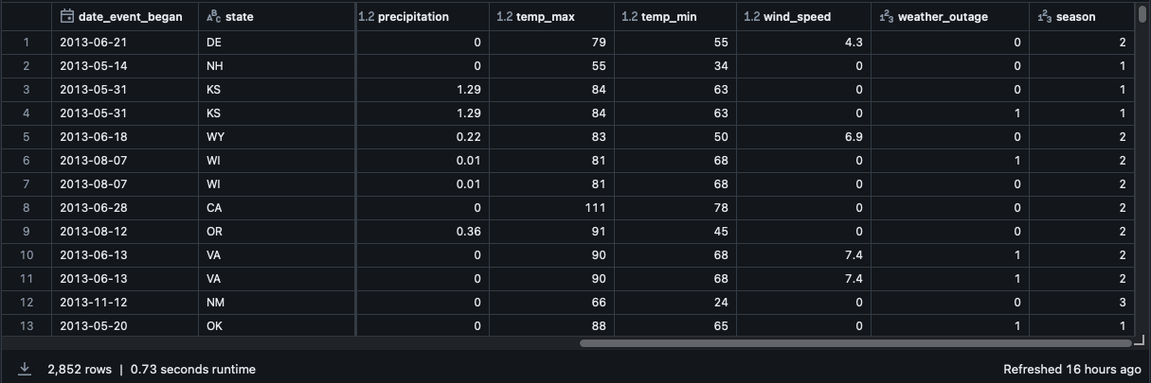
Figure 3 - Example of gold data for data profiling and training and evaluation of ML models
For the machine learning implementation, multiple types of supervised learning models and algorithms were compared with one another, alongside varying feature sets. The feature sets consisted of some or all the following features, minimum temperature, maximum temperature, wind speed, precipitation, and season. The machine learning models created included logistic regression, random forests, gradient boosting, and an ensemble algorithm as well. These models and the feature importance based on different feature sets were evaluated to determine the most optimal model for weather outage predictions given a dataset of power grid outages coupled with daily weather data across a state. The final gold dataset was split 80/20 for training and testing of the models.
The logistic regression model served as a baseline for the binary classification problem. The results from this model are easily interpretable and provide fast training and predictions. The logistic regression model was implemented using PySpark ML libraries with maxIter=10. The random forest classifier was implemented with 100 trees and maxDepth=5. The maximum tree depth was set to 5 to prevent overfitting. These models are optimized for handling non-linear relationships and provide enhanced feature importance analysis. The gradient boosting trees were configured with maxIter=100, maxDepth=5, and stepSize=0.1. In more detail, there were a maximum of 100 boosting iterations, and tree depth of 5 for individual weak learners, and a learning rate of 0.1 for gradient updates. This model used a sequential ensemble learning approach and is specialized for capturing complex patterns. Lastly, the ensemble algorithm or voting classifier provided a prediction based on hard voting or majority voting of the combined models above. Ensemble models provide robust error handling and prediction consolidation which is generally preferred for production grade models. All models were trained and evaluated on an 80/20 train-test split, with standardized input features and binary classification outputs indicating weather-related (1) or non-weather related (0) outages.

- Results & Findings
The gold data with multiple features was first profiled within the Databricks UI using the available tools within the platform. Preliminary statistical insights can be gained, and outliers can be more easily identified using the data profiling tool as can be seen in the figure below.
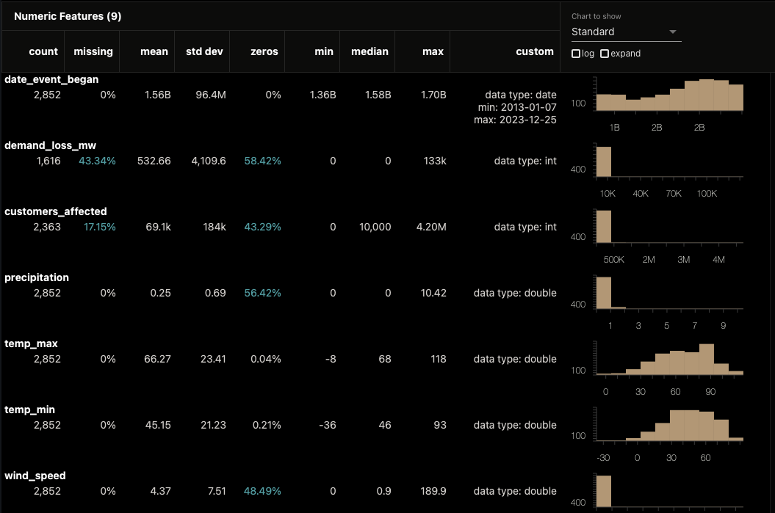
Figure 4 - Data profile generation from gold data
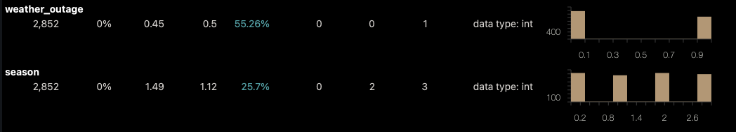
Figure 5 - Weather outage and seasonal data profile analysis
The figures above show the distribution of the data to gain better insight into how the dataset and the features may influence the machine learning models. As can be seen in Figure 5, the percentage of non-weather-related events represented as a value of 0 was 55.26%. Other data visualizations to better analyze the relationships between the various variables can be derived from the processed gold data.
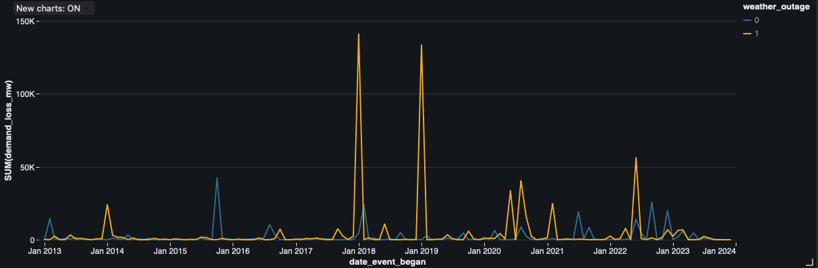
Figure 6 - Demand loss attributed to weather outages across time
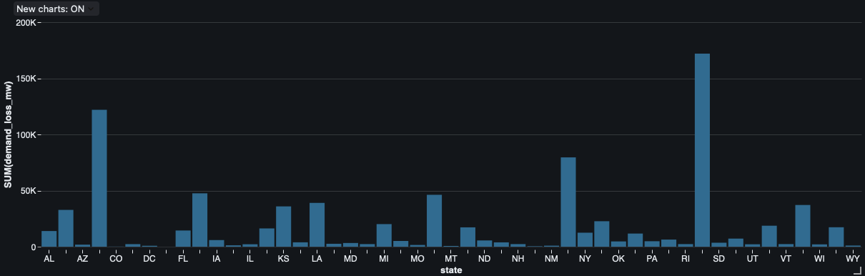
Figure 7 - Demand loss by state

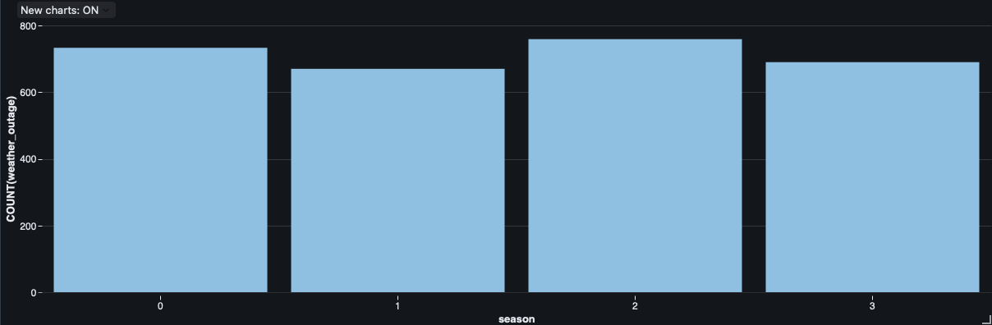
Figure 8 - Weather outages per season where 0 is winter, 1 is spring, 2 is summer, and 3 is fall
The three figures above depict the results from the initial data analysis of the cleaned and processed data to determine the severity of weather outages across time and geographically. Initial analyses show that weather outages generally result in increased demand loss and certain states, or geographical regions are more susceptible to power grid disruptions. Also, a preliminary seasonal analysis was performed showing that there is a slight increase in the number of weather outages in the winter and the summer, likely due to the minimum and maximum temperatures being larger during these seasons.

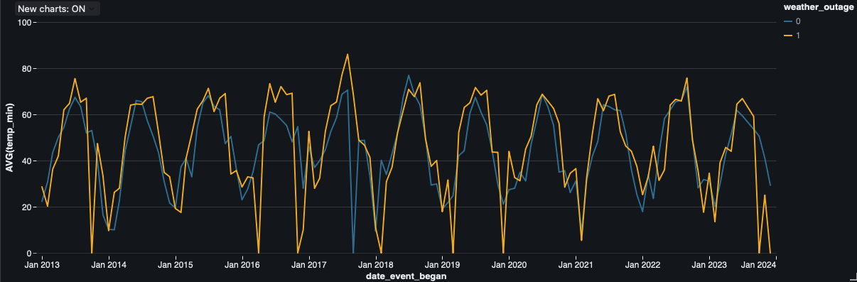
Figure 9 - Average minimum temperatures and weather outages across time
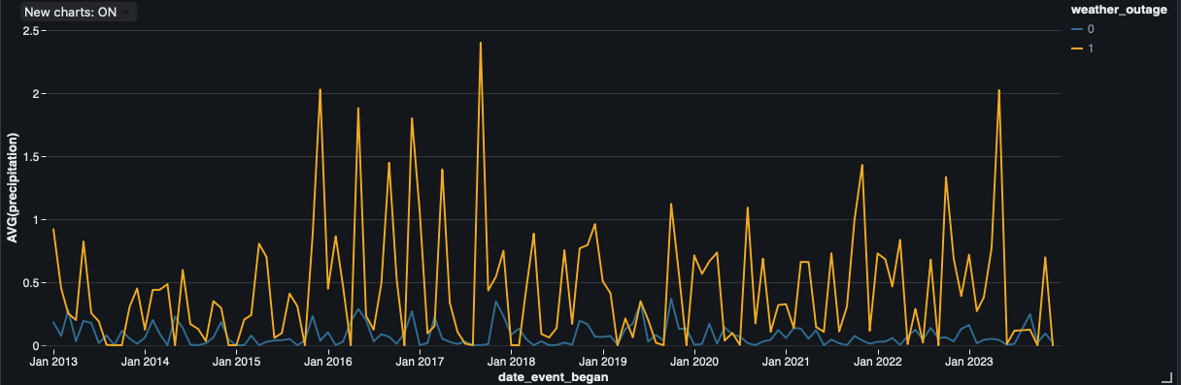
Figure 10 - Average precipitation and weather outages across time
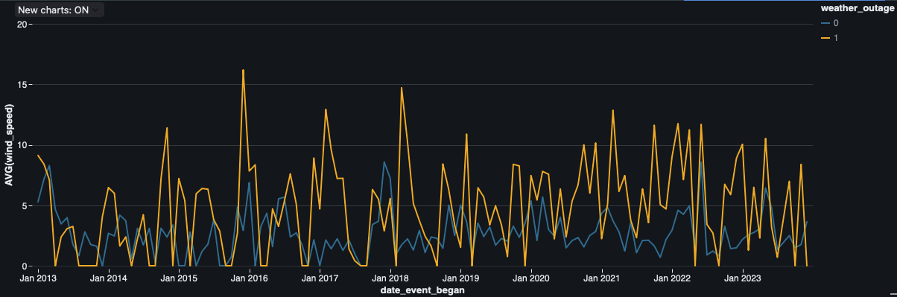
Figure 11 - Average wind speeds and weather outages across time
Thorough data profiling was conducted on the gold data to analyze the relationship between the features and weather vs non-weather outages in the power grid. As can be seen in Figure 9, lower temperatures more closely correlate to weather outages, with maximum temperature exhibiting similar characteristic with more valleys than peaks for weather outages. Figures 10 and 11 show a significantly higher correlation between the precipitation and windspeed compared to weather outages. These analyses prove that using these features when developing the ML models had potential to demonstrate promising results.
All models were trained with 80% of the dataset and tested and evaluated with 20% of the dataset. Accuracy of the models can be derived from the confusion matrix with the equation, (TP + TN) / (TP + TN + FP + FN), where TP is True Positives, TN is True Negative, FP is False Positive, and FN is False Negative. Various performance metrics were obtained from each model including model accuracy percentage, AUC (Area Under the Curve) scores, precision, recall, and corresponding confusion matrices. AUC scores provide insights into the model’s ability to differentiate between the classes, or in this case the weather outage events vs non-weather outage events. An AUC score closer to 1 implies that the model was able to perfectly distinguish between weather vs non-weather outages. Precision scores were determined by analyzing the number of outage records the models correctly identified as weather-related outages, which can also be provided as TP / (TP + FP). Recall scores were determined by analyzing the actual weather outages and calculating how many of those records were classified accurately by the models, given by the equation TP / (TP + FN).

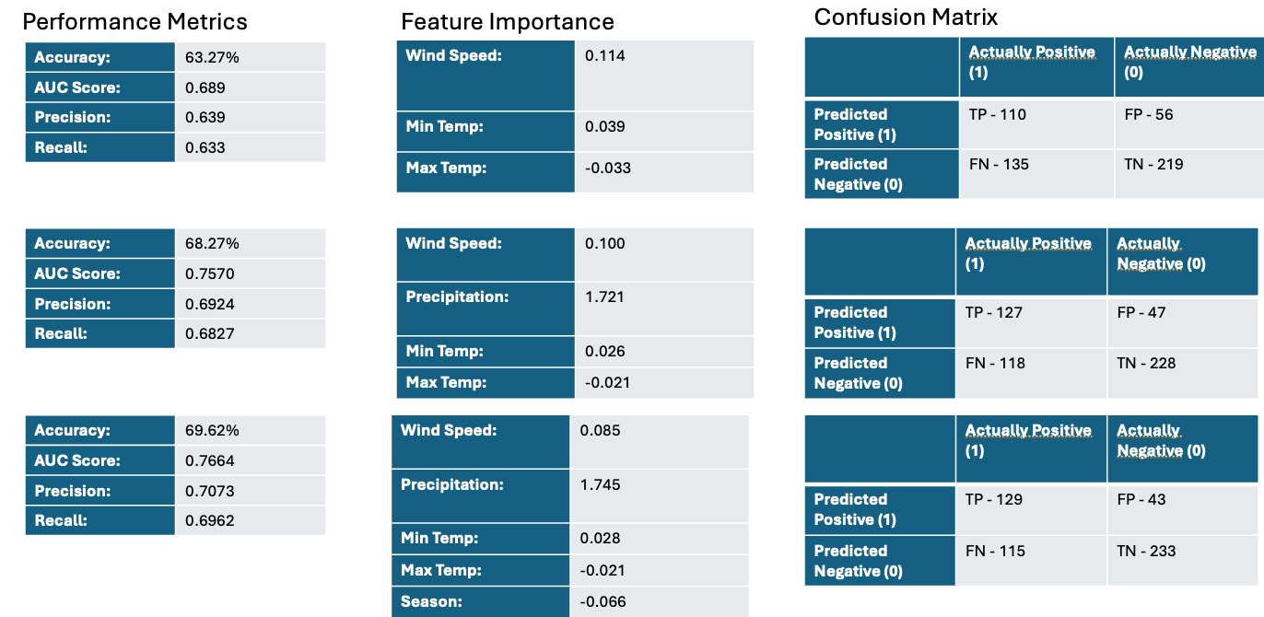
Figure 12 - Logistic Regression results for varying number of features per row
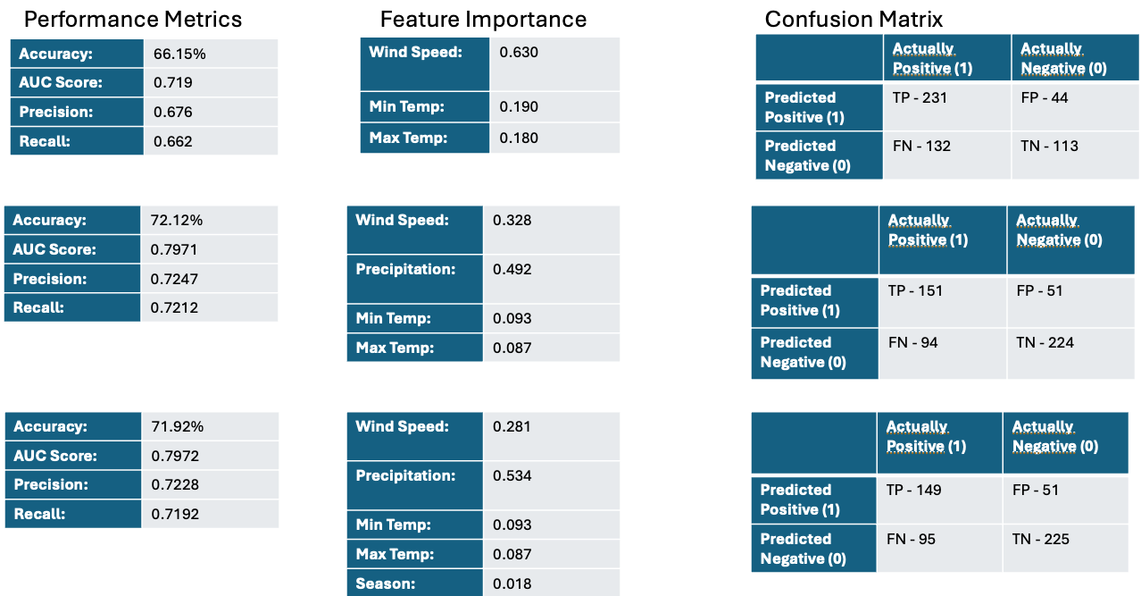
Figure 13 - Random Forest results for varying number of features per row
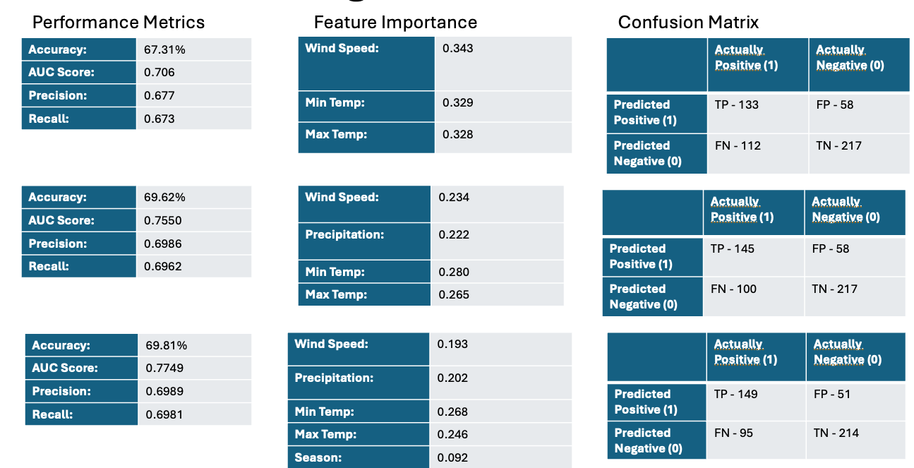
Figure 14 - Gradient boosting results for varying number of features per row
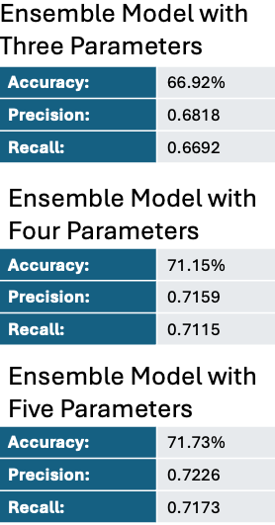
Figure 15 - Ensemble algorithm results with varying number of features
The figures above display the results from the various models and ensemble algorithms with the varying features. Analyses of the feature importance distributions were also reviewed to determine important features for predicting weather outages in the power grid. The model performance analysis for the logistic regression model showed a maximum accuracy of 69.62% with a 6.35% increase in accuracy when utilizing all five features compared to just the initial three features. The AUC score of the final model was 0.7664 with precision score of 0.7073 and recall score of 0.6962. The precipitation coefficient was 1.745, indicating that this was strongly correlated to identifying weather outages. The random forest results had the best accuracy with all features except for season, with an accuracy of 72.12%. The AUC score was 0.7971, precision score was 0.7247, and recall score was 0.7212. The random forests model had the highest accuracy of all models with the feature importance distribution highlighting the more relevant weather data features corresponding to weather outages. The random forest’s model’s superior performance can be attributed to its ability to capture non-linear relationships between weather parameters, particular evident in its handling of multiple weather conditions specifically wind speed and precipitation data. The gradient boosting model’s final accuracy was 69.81%, AUC score of 0.7971, precision score of 0.6989, and recall score of 0.6981. The feature distribution was more evenly distributed for the gradient boosting model as can be seen in Figure 14. Lastly, the final ensemble model’s algorithm had a higher accuracy with the inclusion of all available features at 71.73%, with a precision score of 0.7226, and recall score of 0.7173. The results show a progressive improvement overall with additional variables being include within the feature set. The ensemble algorithm’s accuracy was likely pulled down by the underperforming models compared to the random forest model individually, which can be addressed by identifying and use models that can better derive relationships between the classification target and the available features. The ensemble model’s performance compared to the individual models demonstrates the tradeoff between model aggregation and individual model excellence.
The feature importance distribution allowed for thorough impact analysis per model. The results showed in general that minimum temperatures were more closely related to identifying weather outages than maximum temperatures. The highest correlated weather metrics were precipitation and wind speeds. These results can be better understood by identifying more granular details about severe weather conditions, which mostly consist of thunderstorms, snowstorms, and cold weather. These results align with intuitive weather conditions that are more likely to cause power grid disruptions. The season feature provided minimal improvements to the model when compared to raw weather data metrics showing that the addition of temporal data was not necessarily a reliable predictor in comparison to the other features. With the addition of geographical context with the temporal data, the accuracies and feature importance metrics would likely have shown a more significant improvement.
Overall, for baseline metrics and quick assessments utilizing logistic regression models is most optimal. For the best accuracy given the dataset created and analyzed for this research, the random forests model should be used. For more balanced analysis and weighting of multiple features, gradient boosting should be used. For production grade machine learning algorithms, ensemble models that utilize hard or soft voting mechanisms should be used to reduce individual model biases, generate more stable predictions, and overall leads to better generalization.
The impact of this research shows a proof of concept for developing a comprehensive data engineering pipeline using a modern distributed processing platform for developing machine learning models to predict weather outages in the power grid. The experiment shows high predictive capabilities ranging from 70-72% accuracy, with increasing accuracy with the addition of highly correlated features such as wind and precipitation. Practical applications of this research can be applied in the power grid industry allowing utility companies to forecast predictive maintenance and optimize resource allocation and funding based on weather forecasts. Additionally, more enhanced risk assessments can be conducted for infrastructure planning.

- Optimizations and Enhancements
The research conducted proved to be an effective implementation of machine learning in real-world power grid and weather datasets. Throughout experimentation, various pain points were identified which could have been improved further. The addition of relevant features proved to increase model accuracy, and with additional weather data metrics such as snow depth, lightning strikes, natural disasters, and other more severe weather indicators would have very likely further increased performance of the model. The addition of geographical features with an emphasis on the different climate regions within the US would also have allowed for better temporal analyses. The incorporation of power grid infrastructure age data would also increase accuracies when predicting whether a weather-related outage would occur. Additional considerations such as number of data points and gather more granular weather data would likely have further improved performance metrics.
The machine learning implementations could be further optimized in future works. The models undergoing more thorough hyperparameter fine tuning and experimenting with deep learning implementations such as Recurrent Neural Networks (RNN) and Long Short-Term Memory (LSTM) with an increased amount of data would likely lead to more accurate and robust predictions.

- Conclusion
The research conducted throughout this paper demonstrated the successful implementation of a comprehensive data engineering pipeline using Databricks and machine learning models to predict weather-related power outages. The study analyzed historical power grid outage data alongside NOAA weather data in the US, implementing multiple machine learning models through a structured ETL process using Databricks’ Medallion Architecture. Random Forest models achieved the highest accuracy at 72.12%, while the ensemble algorithm reached 71.73% accuracy, showcasing the potential for machine learning for outage prediction. Precipitation and wind speed emerged as the most significant predictive features, with the addition of other relevant severe weather metrics showing a high likelihood of further improving the accuracies of the models. This work established an advanced data analytics approach for proactive power grid management allowing utility companies to better anticipate and prepare for weather-related disruptions.

References

[1] L. Shen et al., “A flexible ensemble algorithm for big data cleaning of pmus,” Frontiers in Energy Research, vol. 9, Jul. 2021. doi:10.3389/fenrg.2021.695057

[2] Z. Huang, J. Jiang, W. Ma, K. Liu, and L. Zou, “Forecast of power grid material demand based on random forest,” 2022 International Conference on Artificial Intelligence in Everything (AIE), pp. 227–231, Aug. 2022. doi:10.1109/aie57029.2022.00049

[3] Y. Hou, R. Yang, Y. Xiong, Z. Tan, and Y. Xie, “Simulation of cascading faults of power grid under extreme ice and snow weather based on BPA,” 2023 IEEE 11th Joint International Information Technology and Artificial Intelligence Conference (ITAIC), pp. 298–302, Dec. 2023. doi:10.1109/itaic58329.2023.10408785

[4] K. W. Hoiem et al., “Comparative study of event prediction in power grids using supervised machine learning methods,” 2020 International Conference on Smart Energy Systems and Technologies (SEST), pp. 1–6, Sep. 2020. doi:10.1109/sest48500.2020.9203025

[5] D. Kaur, R. Kumar, N. Kumar, and M. Guizani, “Smart Grid Energy Management using RNN-LSTM: A deep learning-based approach,” 2019 IEEE Global Communications Conference (GLOBECOM), Dec. 2019. doi:10.1109/globecom38437.2019.9013850

[6] U.S. Energy Information Administration, "Annual Electric Power Industry Report, Form EIA-861 Detailed Data Files," U.S. Department of Energy, Oct. 10, 2024. [Online]. Available: https://www.eia.gov/electricity/data/eia861/. Accessed: Dec. 2024.

[7] National Oceanic and Atmospheric Administration, "Climate Data Online (CDO) Web Services v2," National Centers for Environmental Information. [Online]. Available: https://www.ncdc.noaa.gov/cdo-web/webservices/v2. Accessed: Dec. 2024.

